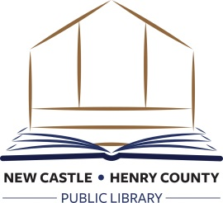

JOB POSTING

Part-Time Children’s Services Assistant

The New Castle-Henry County Public Library is seeking a part-time children’s services assistant who will provide friendly, high quality customer service to Library patrons in the children’s department. Some responsibilities include:

- Provides assistance to patrons in using and locating materials in the children’s department.
- Charges and discharges books and other library holdings in and out at the children’s circulation desk and collects fines using an automated circulation system.
- Replaces books and other library holdings on shelves according to numbering sequences.
- Assists in assuring accurate library shelving by shelf-reading and re-shelving of materials, as needed.
- Answers telephones and provides routine information or refers and transfers calls.
- Oversees the use of computers in the children’s department.
- Assists with programming as requested.

This position requires an individual with a customer service mindset and the ability to serve staff and patrons in a professional, helpful, cooperative, and courteous manner. Candidates must have excellent verbal and written communication skills and possess a good command of the English language in order to interact in a professional manner. In addition, candidates must have expertise and proficiency with computers and computer-equipment, and must be able to successfully use basic office applications and the Internet, including databases and social networking sites.

Minimum Requirements:
- High school diploma or equivalent required
- Library experience preferred but not required
- Must be able to lift 40 pounds, walk, climb stairs, bend, stoop to the ground, reach above one’s head, stand for long periods of time, and must be capable of communicating with and assisting children

Starting Rate: $8.00 per hour
Hours: Evenings and weekends, approx. 15-18 hours per week

To apply, send application and/or resume and professional references to: hr@nchcpl.lib.in.us

